**Instruction sheet**

1) The next phase is very similar to the last. The main difference is that for each of the background pictures you will see two foreground items, one after the other, so each trial will look like this:



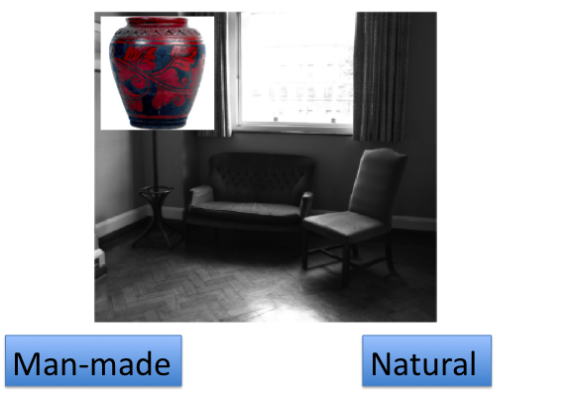

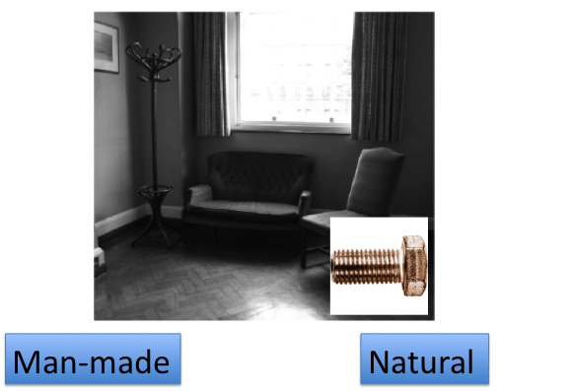

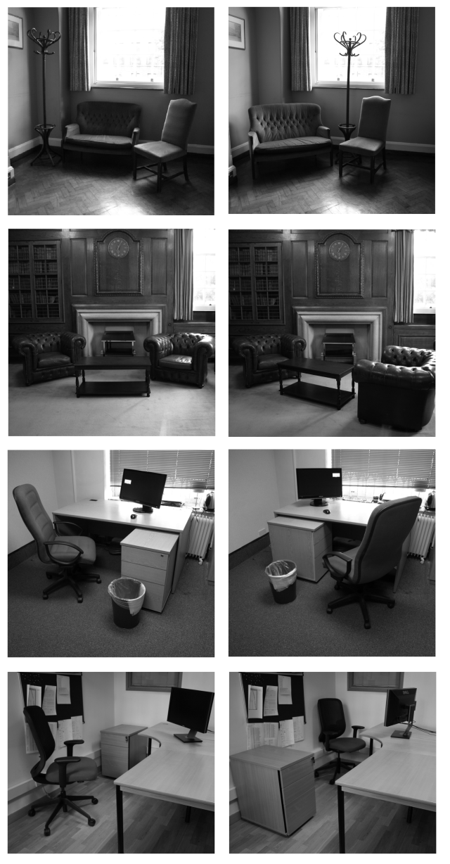

2) The same category that was rewarded before will be rewarded again this time.

**REMEMBER: The money you win on the task will affect how much you take home at the end of session two.**

3) Unlike in the last task, none of the items will be repeated, they will all be new items.

4) Don’t forget that you **MUST** respond, whether there is reward available or not. However if there is reward available, you must respond especially quickly to receive it. You will no longer be told if you were too slow.

If your accuracy for deciding if an item is Natural or Man-made falls too low, you will **not** receive the money that you have made on the task.